

Lille, France, August 15, 2025

<Name Surname>

Subject: Attestation of Participation at the ESUG 2025 Summer School

Dear <Name Surname>,

I attest that you participated in the 32th International Smalltalk Summer School (ESUG) that was held in Gdansk, Poland, from the 28th June, 2025 to the 4th July, 2025.

Please visit the ESUG web site at https://esug.github.io and to find out more information about the event.

Sincerely,

Stéphane Ducasse
stephane.ducasse@inria.fr

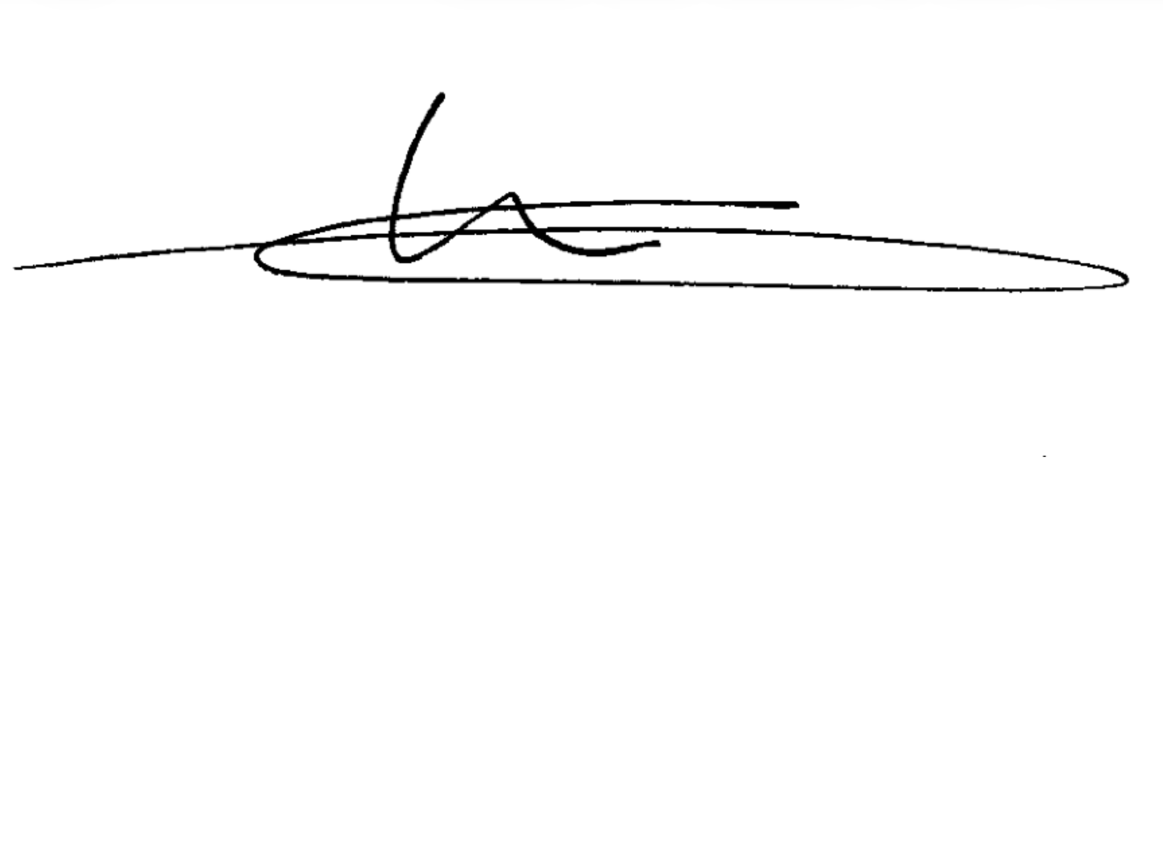
Président du groupe européen d’utilisateurs de Smalltalk
President of the European Smalltalk User Group ESUG
Inria Lille Nord Europe, 40, avenue Halley,
Parc Scientifique de la Haute Borne,
Bât.A, Park Plaza
Villeneuve d’Ascq 59650
France

ESUG Association Loi 1901 n◦W751167780 (not subjected to V.A.T.)
http://www.esug.org c/o Mr. Stéphane Ducasse - 1 rue Cesar Franck - 59800 Lille - France

